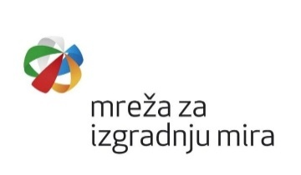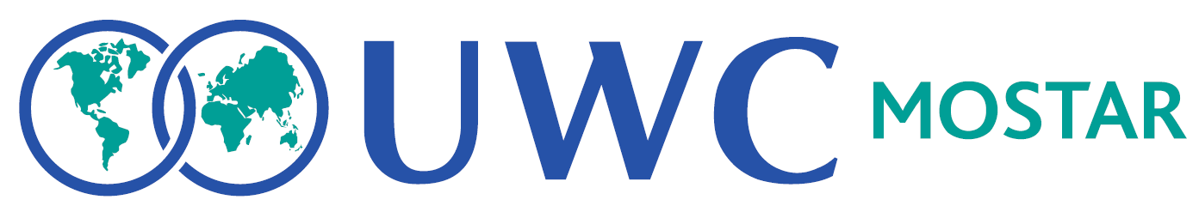
INTERNATIONAL DAY OF PEACE CELEBRATION
MOSTAR, 17–19 SEPTEMBER 2026
DAY I – THURSDAY, 17 Sept 2026  10:30–12:00  National Theatre Mostar/ Studio 64  Workshop: Art – Creative Writing and Painting – Dignitet Association (BHS)  16:30–18:00  National Theatre Mostar/ Studio 64  Workshop: Activism and Development of Local Initiatives – Dignitet Association (BHS)  18:00-19:30  📍 National Theatre Mostar, Brkića 2  Round Table: Practical approaches to inter religious dialogue for peacebuilding  - Friar Ivo Marković, Professor Theology of Bosnian Franciscans  - Prof.dr. Zilka Spahić Šiljak, TPO Foundation, Sarajevo  - Deacon Branislav Rajkovic, Trebinje  - Vladimir Andrle, President of the Jewish Cultural-Educational and Humanitarian Society La Benevolencija  Moderator: Emina Frljak (BHS)  ⏰ 20:00-20:30  📍 National Theatre Mostar, Brkića 2  Peace Award Ceremony Goran Bubalo with a performance “We Are Your Eyes” (BHS)  Host: Sanela Kuko  ⏰ 20:30-21:30  📍 National Theatre Mostar  Film” The Partisan Necropolis”  (ENG & BHS) | DAY II – FRIDAY, 18 Sept 2026  ⏰ 08:30 – 09:00  Welcome Hang Out  ⏰ 09:00-10:00  📍 National Theatre Mostar, Brkića 2  Opening Ceremony Part I (ENG & BHS)  ⏰ 10:30-12:00 (Optional)  Guided visit to Partisan Memorial Cemetery  ( meeting at the entrance of PMC) (ENG & BHS)  ⏰ 10.15 - 11.00  Opening Ceremony Part II  ⏰ 11.15 - 12.15 Panel Discussion: Learning Peace: Rethinking Narratives (ENG)  ⏰ 14.00 - 15.30 Student & Staff Led Workshops (ENG)  (Gimnazija Mostar & Velić & Torlo)  ⏰ 12:30-14:00  📍 United World College Mostar, Španski trg 1  Living Library, conversation with Books (ENG & BHS)  ⏰ 17:00-19:00/ Studio 64  📍National Theatre Mostar/Narodno pozoriste  Workshop on Non-Violent Communication and Neuro Linguistic Programming  Dialogue to Peace  Non-Violent Communication Network BiH, Selma Teparić, and NLP practitioner, Sanela Kuko  (BHS)  THEATRE EVENING  ⏰ 20:00-21:30  📍 National Theatre Mostar, Brkića 2  The Bloodstream of the Stone  Mostar Youth Theatre, (BHS) | DAY III – SATURDAY, 19 Sept 2026  ⏰ 09:00-14:00  📍 United World College Mostar, Spanish Square  Around the World in 80 Minutes (ENG &

Proslava medjunarodnog Dana Mira
MOSTAR, 17–19 SEPTEMBAR 2026
DAN I – ČETVRTAK, 17 Sept 2026  10:30–12:00  Narodno Pozorište Mostar/ Studio 64  Radionica: Umjetnost – Kreativno pisanje i slikanje – Udruženje Dignitet  16:30–18:00  Narodno Pozorište Mostar / Studio 64  Radionica: Aktivizam i razvoj lokalnih inicijativa – Udruženje Dignitet  18:00-19:30  📍 Narodno Pozorište Mostar, Brkića 2  Okrugli sto: Praktični pristupi međureligijskom dijalogu za izgradnju mira  - Fra Ivo Marković, Profesor na Franjevačkoj teologiji u Sarajevu  - Prof.dr. Zilka Spahić Šiljak, TPO Fondacija, Sarajevo  - Djakon Branislav Rajkovic, Trebinje  - Vladimir Andrle, Predsjednik Jevrejskog kulturno-prosvjetnog i humanitarnog društva La Benevolencija  Moderator: Emina Frljak (BHS)  ⏰ 20:00-20:30  📍 Narodno Pozorište Mostar, Brkića 2  Dodjela mirovne nagrade Goran Bubalo, prigodni perfomans “Mi ćemo biti tvoje oči”  (BHS)  Voditelj: Sanela Kuko  ⏰ 20:30-21:30  📍 Narodno Pozorište Mostar, Brkića 2  Film Partizanska nekropola,  (ENG & BHS) | DAN II – PETAK, 18 Sept 2026  ⏰ 08:30 – 09:00  Dobrodošlica  ⏰ 09:00-10:00  📍 Narodno Pozorište Mostar, Brkića 2  Ceremonija otvaranja I dio (ENG & BHS)  ⏰ 10:30-12:00 (Opciono)  Posjeta Partizanskom groblju sa vodičem  ( okupljanje na ulazu groblja) (ENG & BHS)  ⏰ 10.15 - 11.00  Ceremonija otvaranja II dio  ⏰ 11.15 - 12.15  Panel Diskusija:  Učenje mira: Preispitivanje narativa (ENG)  ⏰ 14.00 - 15.30 Radionice koje vode studenti i osoblje (ENG)  (Gimnazija Mostar & Velić & Torlo)  ⏰ 12:30-14:00  📍 United World College Mostar, Španski trg 1  Živa biblioteka, razgovor sa knjigama (ENG & BHS)  ⏰ 17:00-19:00/ Studio 64  📍Narodno pozoriste Mostar/Studio 64  Radionica o nenasilnoj komunikaciji i neurolingvističkom programiranju  Dijalogom do Mira  Mreža nenasilne komunikacije u Bosni i Hercegovini, Selma Teparić i NLP praktičar, Sanela Kuko  (BHS)  Predstava  ⏰ 20:00-21:30  📍 Narodno Pozorište Mostar, Brkića 2  Predstava “Krvotok kamena”  Mostarski teatar mladih, (BHS) | DAN III – SUBOTA, 19 Sept 2026  ⏰ 09:00-14:00  📍 United World College Mostar, Španski trg  Put oko svijeta za 80 minuta (ENG & BHS)

